Question 1: Top 5 orders based on total_revenue
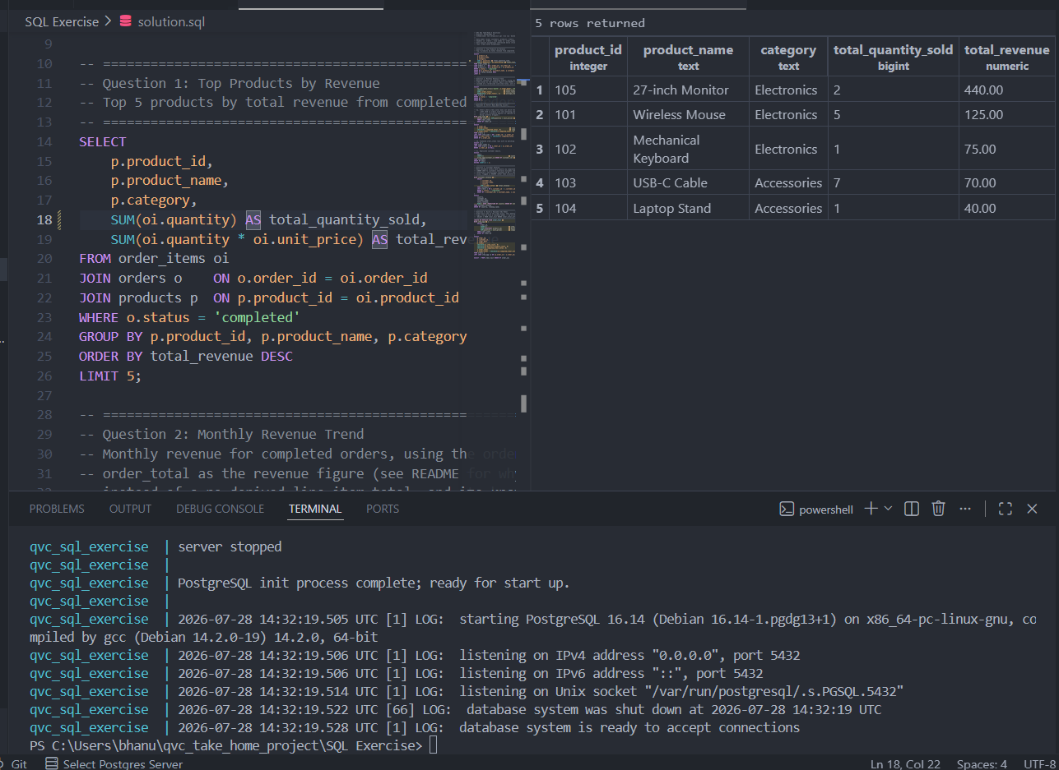
Question 2: Monthly Revenue Trend
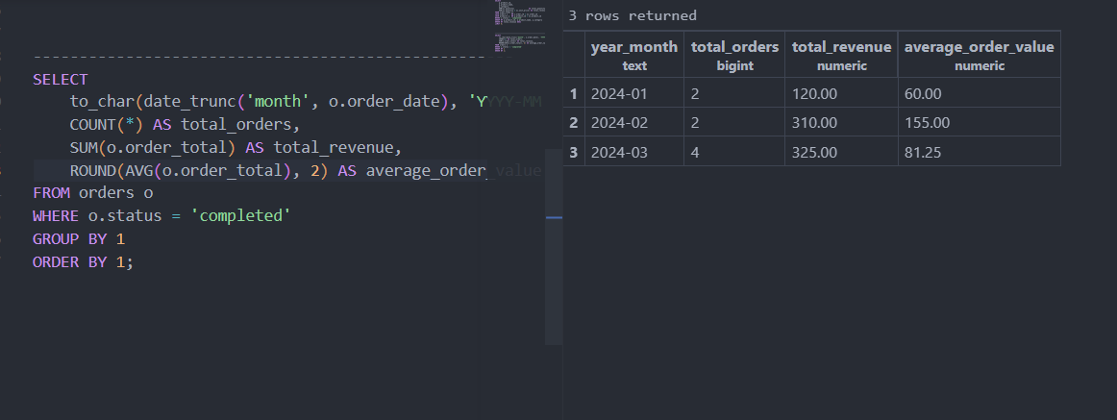
Question 3: Data Quality Isuues
3a: Orders total mismatch
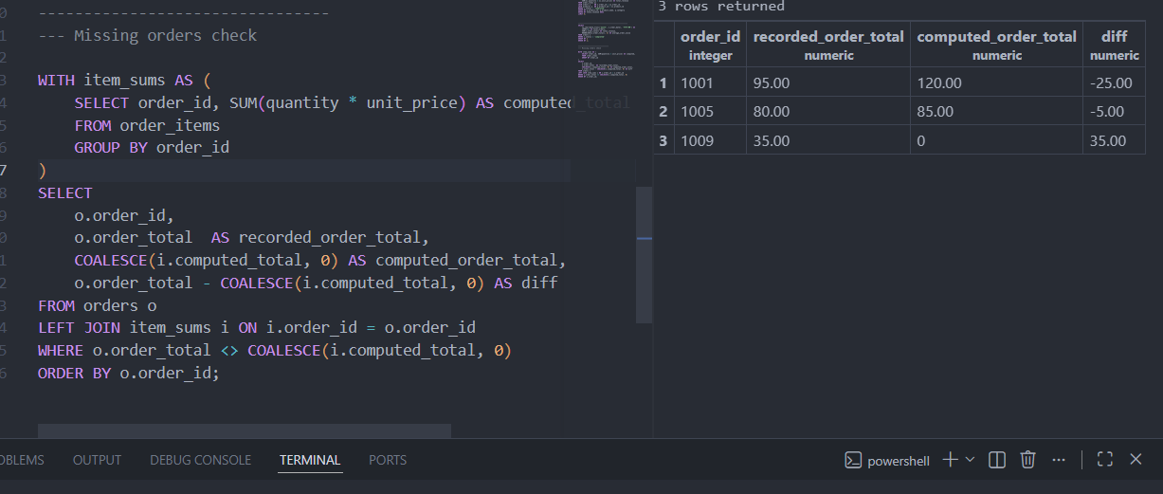
3b: Orphaned order_items compared to orders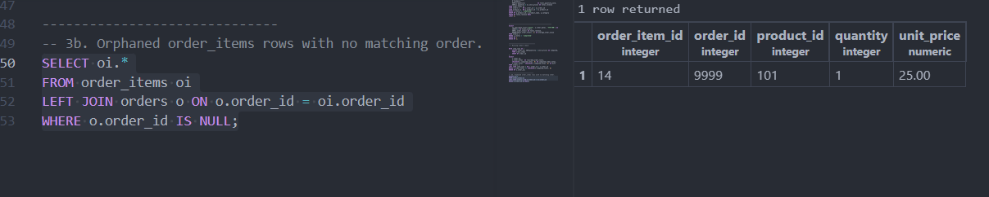
3c: Duplicate Customer Emails
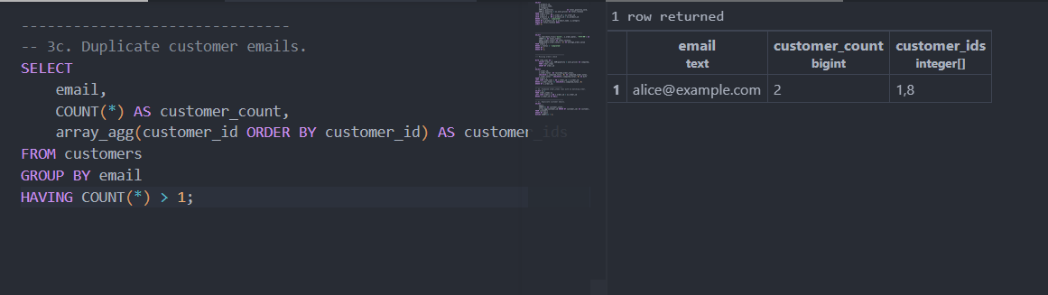

4: Customer Ranking based on Revenue by each country
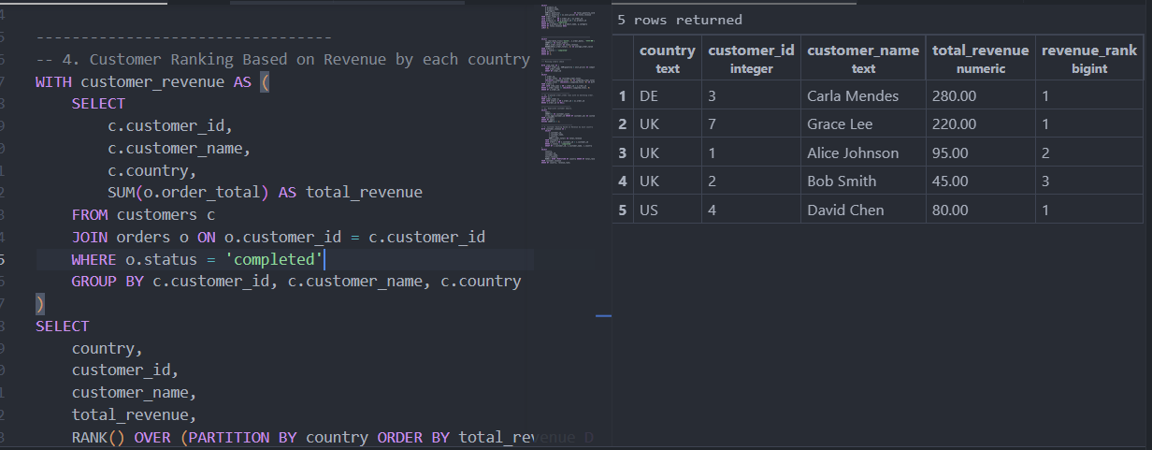
5: Order Fact View
